Appendix D. Technical detail on the tools
The project developed a locally hosted collaborative workspace in two parts, Source Management and the Workbench. Together they cover three systems: regulatory source management, extraction and validation of original content, and requirement decomposition and interpretation.

D.1 Source management
Source Management keeps regulatory source material up to date and tracks newly identified sources. It supports manual source addition, automated scans for updates to existing sources, and LLM-assisted searches for additional relevant sources. For each new source, the program extracts the record fields; a reviewer checks them and decides whether to include or exclude the source. Machine assessments and retrieval status are recorded separately from that decision.
When retrieval fails, the last valid original is kept, and downstream work stays linked to the selected source version. A new version marks affected records for renewed review. Each source record covers six areas:
Area | Fields
Identity and classification | Source ID and document title; issuing authority, jurisdiction and authoritative language; source family, document type and role in requirement extraction.
Access and original evidence | Official URL and retrieval URL; acquisition channel and file format; provenance status and the saved original.
Version and updates | Version and effective date; source status and update model; snapshot identifiers and dates; detected content changes.
Quality and applicability | Authority and currency; scope relevance, inclusion rationale and applicability references; traceability and access permission; readiness for automated processing.
Human decisions and review | Include or exclude decision; person responsible for manual updates and update dates; review notes.
Retrieval status and follow-up | Download and snapshot status; dates of retrieval attempts and successful retrievals; failure details and any required human follow-up.

Tracking sources in software means a change is flagged when a scan detects it, rather than when someone reports it. One question remains open: guidance and inspection practice may define practical assessment criteria for terms such as forsvarlig, nødvendig and tilstrekkelig, and the project has not decided when such material becomes a source. Until source identity and version are resolved, dependent work keeps an explicit pending status.

D.2 HTML and other formats
The HTML module identifies the main regulatory content on supported webpages and converts it into Markdown, preserving headings, paragraph order, lists and tables while removing navigation and other surrounding elements. Reviewers compare the Markdown with the original webpage in the Workbench and correct capture errors there.
The tools also support Excel (XLSX), retaining worksheet and cell references for review. In our operational workflow, HTML accounts for 90% of the material and formats other than HTML and PDF are rare. We therefore reserve a separate LLM-assisted processing route for these special cases.

D.3 PDF extraction and Depth-Controlled Cross-Validation
The program includes its own PDF extraction, but the Evidence team (Abhilash Iyernadig and Zhizhen Li) has developed more targeted extraction using LLM image and LLM chat. We reuse their work and focus on checking the result. Depth-Controlled Cross-Validation checks one candidate extraction against several different readings of the same original. Because methods handle text and layout differently, comparing their readings can expose omissions, changed values and misplaced table entries. Discrepancies stay linked to the original for human review. The proposed combinations below match methods to the content being checked.
Document type | Full-page extraction | Content to compare | Proposed methods, Depths 1 to 4
Requirement: Regulatory PDF (text) | Evidence PDF workflow | Wording, numbers, negation and paragraph coverage. | Poppler; pdfplumber; Docling; PP-StructureV3
Requirement: Regulatory PDF (scan) | Evidence PDF workflow | The same text and coverage checks, read from page images. | Tesseract; Docling; PP-StructureV3; MinerU Basic
Evidence: Product certificate (text) | PDF Inspector | Field labels, values, units and the product they describe. | pdfplumber; Tesseract; Docling; PP-StructureV3
Evidence: Product certificate (scan) | LLM image | The same field-to-product relationships, read from page images. | Tesseract; Docling; PP-StructureV3; MinerU Basic
Evidence: User manual | LLM image: sections | Selected sections, including headings, paragraphs, lists and reading order. | Tesseract; Docling; PP-StructureV3; MinerU Basic
Evidence: Deployment report | LLM image: tables | Cell values, row and column headers, units and merged-cell relationships. | PP-StructureV3; Docling; Table Transformer; MinerU Basic
Evidence: Facility certificate | LLM image: tables | Cell values, row and column headers, units and merged-cell relationships. | PP-StructureV3; Docling; Table Transformer; MinerU Basic

Depth 1 uses the least costly suitable method. Depths 2, 3 and 4 keep the earlier comparisons and each add one further method, increasing both cost and evidence. Depth 5 adds an LLM different from the upstream extractor and receives the largest review budget. The candidate and the source scope stay fixed at every depth. Appendix E links to each method.
Method | Use in cross-validation | How it reads the source
Poppler | Regulatory text, numbers and omissions. | Reads selectable PDF text for direct comparison.
pdfplumber | Certificate fields and positioned text. | Reads text and coordinates; comparison links values to nearby labels and units.
Tesseract | Scanned text, fields and manual sections. | Reads page images; comparison aligns its output to source-defined fields or sections.
Docling with TableFormer | Sections, reading order and table cells. | Combines layout analysis, text reading and table structure recognition.
PP-StructureV3 | Document blocks and table content. | Combines visual layout analysis, text recognition and table reconstruction.
MinerU Basic | An additional reading of sections or tables. | Uses a local model pipeline to produce structured content without a generative vision-language model.
Camelot | An alternative for tables with selectable text. | Uses ruling lines or text alignment to recover rows and columns; the parser is chosen to suit the table.
Table Transformer with text recognition | Table cell content and header relationships. | Detects table structure; a text reader supplies the cell values for comparison.
Other LLM | A further source-based check at Depth 5. | Uses a different model from the upstream extractor to compare the original with the same candidate, including contextual relationships.

The workflow produces extracted text and tables with page references, together with a structured JSON validation report. The report records the methods and depth used, the comparison results and the discrepancies, each linked to the relevant source content, so reviewers can check flagged passages or cells against the original PDF before the content moves downstream.

D.4 Requirement structuring and interpretation
Requirement structuring has two steps: preserve the structure of the legal text, then interpret each resulting entry as Scope, Demand and Condition.
Nesting with constraints. The source is stored as a tree of clauses, Groups, fragments and references. A role field identifies Subject, Modal Verb, Main Verb, Object, conditions, exceptions or subrequirement. Nested Groups can require all of their items or at least one alternative. Shared conditions stay attached to the clause or Group they qualify, and linked entries keep their own structure and conditions. Figure 2 shows how the JSON fields preserve the original wording, constrain nested Groups and link complete Requirement entries.
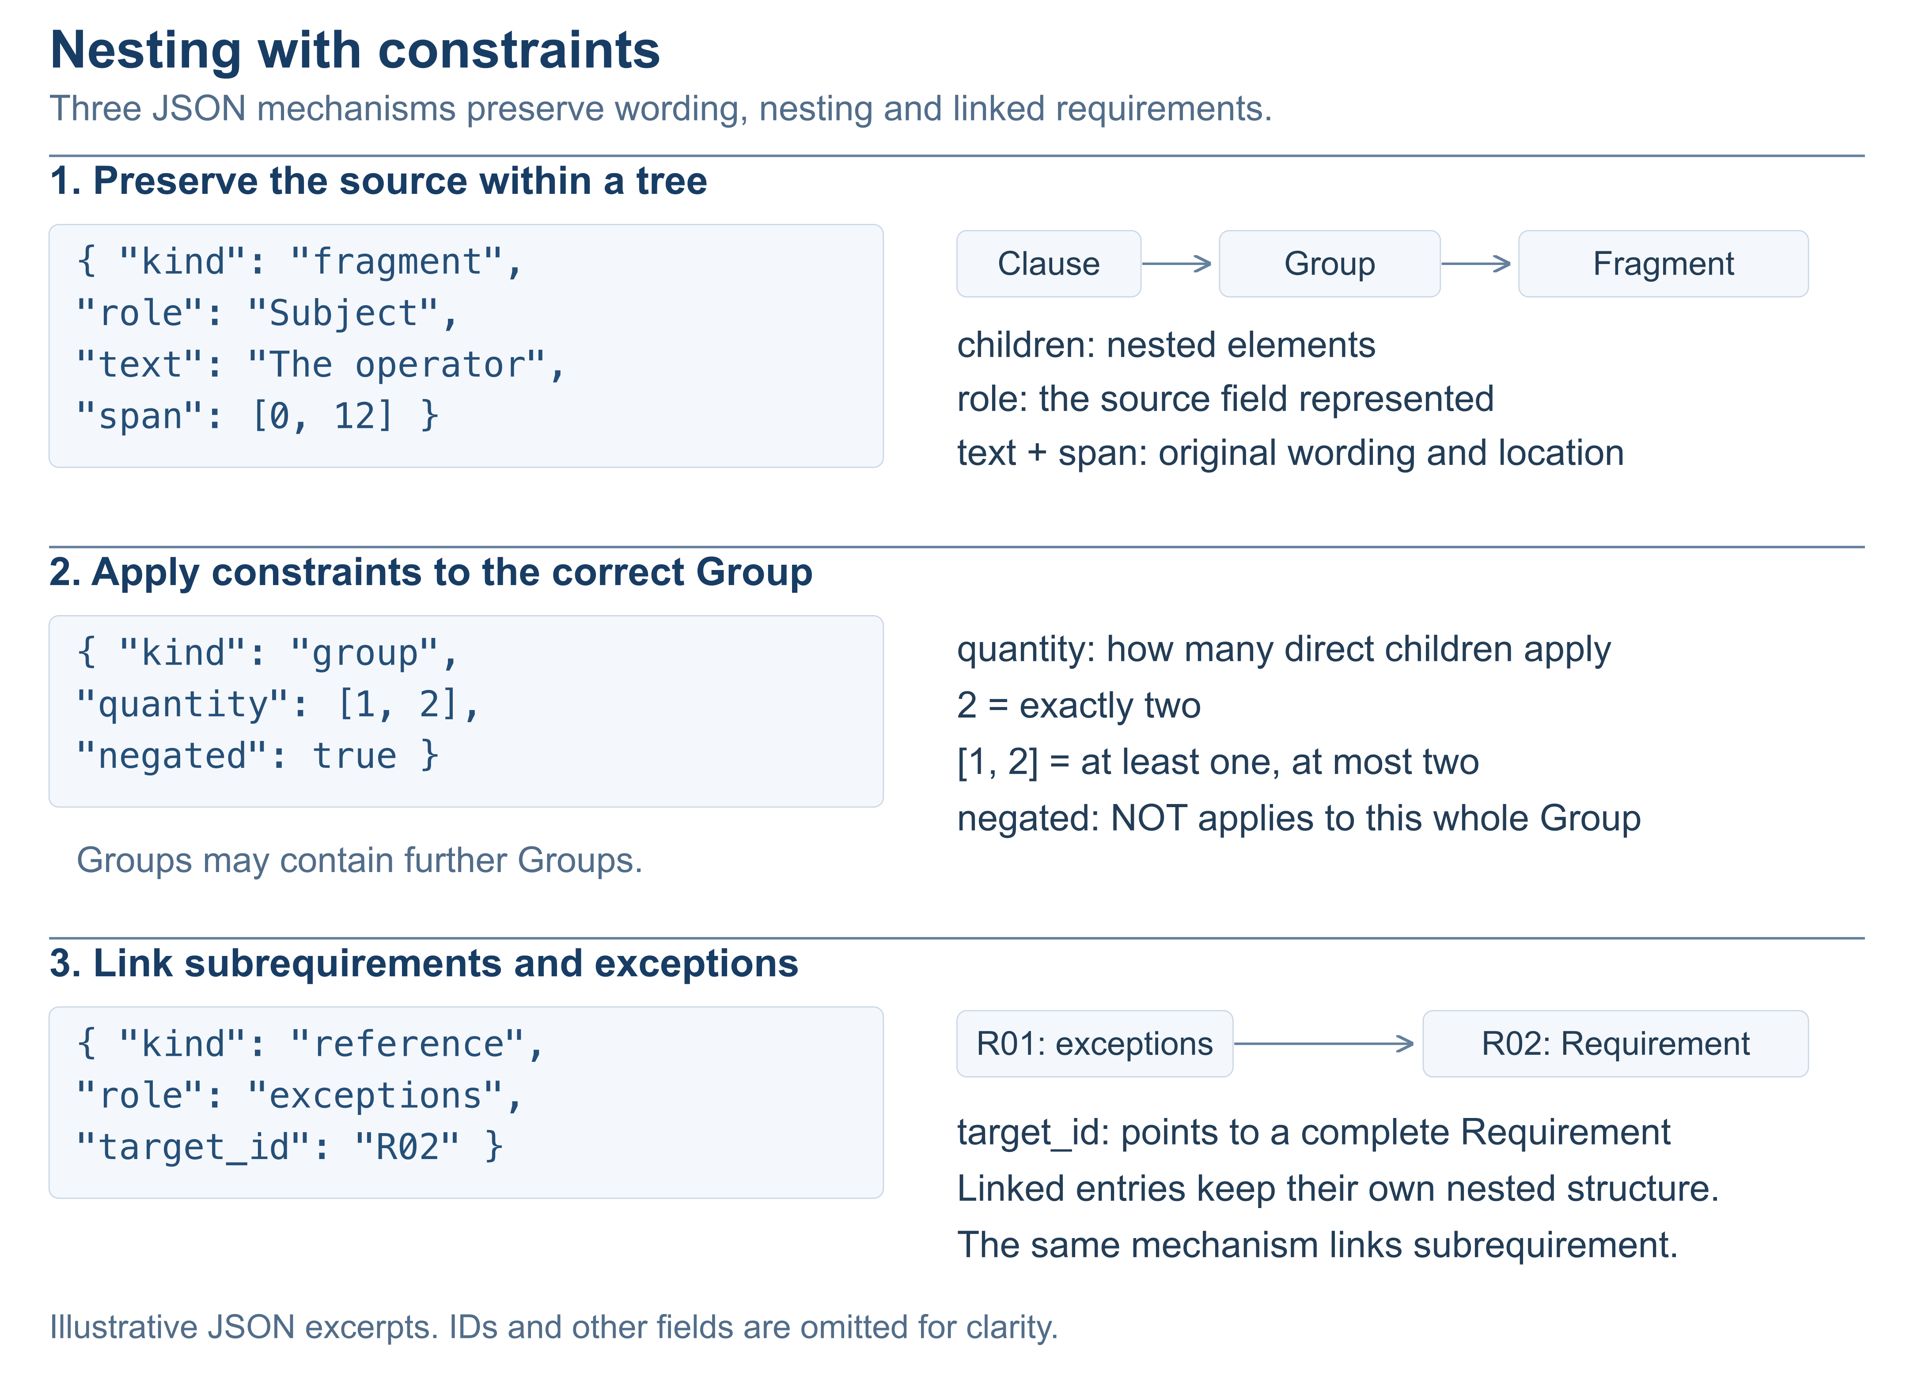
Figure 2. Nesting in the Workbench: source text and nested children, Group quantity and negation, and reference links to subrequirements and exceptions. JSON excerpts use current Workbench field names.
In the R09 example, the storm trigger stays with the parent, while inspection and recording remain two child duties. Both keep the trigger after decomposition, so each duty is available for later checks without losing the dependency a flat list would drop.
Mapping to Scope, Demand and Condition. The program combines the recorded JSON fields and nested Groups into source extracts. These extracts, linked Requirements and the surrounding material are the evidence for interpreting each component:
Component | What the program supplies | What the LLM does
Scope: which objects to assess | Subject as the initial extract, with Object, linked clauses and the surrounding source context. | Identifies the regulated object domain, proposes the Scope definition and specifies the information needed to identify those objects. The grammatical Subject is evidence; it does not define Scope automatically.
Demand: what those objects must satisfy | Modal Verb, Main Verb and Object, with linked subrequirement entries and Group quantities. | Interprets the required action or state and keeps source-supported limits, frequency and other qualifications. Conditions on how the duty is performed stay part of Demand.
Condition: when the requirement applies | Conditions and linked exceptions, with their nesting, ownership and Group constraints. | Separates applicability triggers from qualifications on Demand and identifies which objects within Scope are subject to the requirement, keeping whether conditions apply together, as alternatives or as an exemption.

The LLM receives the saved structure, linked Requirements, source passages and citation IDs in one context. It proposes predicates for check_design.groups.scope, check_design.groups.demand and check_design.groups.condition, combined through nested AND and OR groups and explicit NOT operators. The program checks the returned JSON structure and source quotations, and reviewers confirm the interpretation and any inferred relationships before accepting the candidates.
The target output is a clearly defined Scope, Demand and Condition entry for the downstream Site Model. Its nested AND, OR and NOT logic is kept in structured JSON, and supported field mappings use QueryBuilder-compatible filters. The JSON handoff preserves the definitions, logical relationships and source references needed for downstream query design.

D.5 Workbench design
- Review the source and its interpretation together. Four resizable panes show the original document, extracted content, requirements, and interpretation and check design. Source links let reviewers move between a requirement and its evidence without losing context. Original files stay unchanged, and human corrections are saved separately.
- Edit structure without losing meaning. Nested Groups keep quantities, AND and OR relationships, exceptions and subrequirement links. Grouping, ungrouping and reordering preserve these relationships through stable identifiers. Undo, redo and table-cell editing support corrections while keeping source references.
- Keep decisions and revisions traceable. Draft saving, model-candidate acceptance, approval of Scope, Demand and Condition, and completion are separate steps. Version checks surface conflicting edits, and source changes mark affected downstream work for review. Author and revision history stay available, with warnings for unsaved work and recovery for interrupted imports.
- Collaborate through controlled local exchange. Each colleague runs a local installation with request and reviewer-session checks. Saved work is exchanged as ZIP packages containing sources, records and history, excluding credentials and runtime settings. Import checks integrity, previews differences and merges accepted records. HTML previews are cleaned and sandboxed, and remote AI calls require an explicit action and configuration.

D.6 Authoring-assistant review: patterns and outcomes
We reviewed the assistant’s structured fields, generated sentences and replacement suggestions using clause-level and complete-text inputs. The casebook combines regulatory excerpts with constructed clauses to examine three mismatch patterns:
- M1. Normative language. Obligations, prohibitions and permissions can be expressed through forms such as must, is required to and is prohibited, beyond the assistant’s fixed verb vocabulary. Normalisation must preserve their legal force. A missing literal selector is a boundary to test, not proof that meaning was lost.
- M2. Verifiability. Authoring rules favour standalone, precisely measurable requirements. Applied directly to regulations, they can misclassify useful context or qualitative obligations and suggest numerical thresholds the source never set. The review has to separate missing verification evidence from a defect in the legal requirement itself.
- M3. Context dependence. A clause can depend on a parent provision, shared condition, nested list, exception, reference or another sentence. Splitting it into separate entries can remove these connections or change which duties a condition governs, so the result has to be reviewed with its source context.
We tracked six possible outcomes separately from the mismatch patterns, distinguishing visible failures from risks the captures did not confirm:
Outcome | Evidence from the reviewed cases | Finding
O1. No matching field | A source expression has no direct field or selector. However, R02 preserved the prohibition in is prohibited, and the isolated R13 output recognised is required to as an obligation. | Not established as a semantic failure.
O2. Content omitted | R01 lost the Operator definition or produced no structured entries for scope, purpose and definition. The complete-text R13 output omitted the duty to provide training records on request. | Observed omission.
O3. Meaning rewritten | R08 made the five-year maximum conditional on need. In R16, A means medicines added and B means discharge away from the facility: A AND B became NOT A OR NOT B, while the Condition field stayed correct. The pilot also suggested eight hours of training and an 80% score without source support; adoption was not shown. | Observed changes and unsupported suggestions.
O4. Relationships flattened | In the isolated R09 split, inspection and record retention both lost the shared storm trigger. The actions survived, but the condition governing both did not. | Observed relationship loss.
O5. Subrequirements or exceptions detached | A child duty or exemption could lose its target, changing applicability. The reviewed R03 and R10 captures kept the visible exception target and did not show attachment to an unrelated duty. | Risk identified; not established by these captures.
O6. Scope, Condition or Demand misassigned | R05 made Competence perform the action of documenting competence. R18 made Notification submit itself. Responsibility, action, regulated object and evidence were not reliably distinguished. | Observed role and field errors.

Patterns and outcomes are not one-to-one: one mismatch can produce several consequences, and field errors can occur without an identified mismatch. The cases establish specific failures and controls, not an overall accuracy rate. A plausible field or a Verifiable label does not show that the original obligation, condition and relationships survived.

D.7 Acceptance steps
- Accept the company input contract. Obtain an actual PDF and JSON pair and check page identity, coordinates, block types and source coverage. Validate the implemented block-level evidence alignment and effective-depth reporting against these inputs.
- Measure extraction and review quality. Integrate the proposed method combinations in D.3 and benchmark each depth on independently labelled examples. Measure missed errors, false alarms, review time and cumulative cost, including the additional errors each method finds. Use merged tables, scans, small text and complete section omissions to test coverage. The results should set the method order and default depth.
- Run one narrow compliance check. Start with a reviewed requirement, define its population and period, connect operational data and record how missing evidence is treated. Validate the assessment before generalising the mapping; source fidelity, interpretation and data correctness each need review.
- Evaluate model assistance on retained passages, rejected candidates, corrections and reasons. Test changes on separate cases before choosing between prompting, retrieval and fine-tuning. Fine-grained PDF model review remains an implementation task. LLM-assisted requirement interpretation needs live integration testing and acceptance evidence.
- Complete environment and workflow acceptance. Test native Windows operation and realistic document sizes, along with evidence access, unsaved-work preservation, conflict resolution and review completion. Check whether review effort falls while decisions and history stay intact.

